SUSTAINABLE SMART CITY

ASSISTANT USING IBM GRANITE LLM

### TEAM MEMBERS

## Vaishnavi S.G

## Vaitheeswari .D

## Viveka .A

## Yashine .G

### AGENDA

## 

## → Introduction

## → Project Overview

## → System Architecture

## → Key Features

## → Benefits

## → Challenges

## → Future Scope

## → Conclusion

### INTRODUCTION:

# ­­­­ A Sustainable Smart City is an urban area that leverages advanced technologies, data-driven systems, and eco-friendly practices to improve quality of life while ensuring environmental protection and resource efficiency. It integrates smart infrastructure, renewable energy, green mobility, efficient waste management, and digital governance to create cities that are not only intelligent and connected but also sustainable for future generations.

# The main goal is to balance economic growth, social well-being, and environmental responsibility, making cities resilient, livable, and inclusive.

### PROJECT OVERVIEW:

## A Sustainable Smart City project integrates technology, renewable energy, and eco-friendly infrastructure to improve quality of life, ensure efficient resource use, and promote environmental sustainability.

### ∎PURPOSE OF THE PROJECT:

## → To improve quality of urban life through technology-driven services.

## →To reduce carbon footprint and ensure eco-friendly urbanization.

## →To optimize resource usage (energy, water, waste).

## →To enable real-time decision-making using data and AI.

## → To make cities inclusive, resilient, and future-ready.

## 

### ∎OBEJECTIVE OF THE PROJECT:

## → Ensure sustainable development with minimal environmental impact.

## →Provide efficient, citizen-centric services (transport, healthcare, energy, governance).

## →Integrate renewable energy sources into city infrastructure.

## → Develop data-driven decision-making systems for city management.

## → Enhance urban safety, security, and resilience against climate change and disaster

## → Foster economic growth through innovation and digital transformation.

### 

### System Architecture:

## A sustainable smart city architecture is typically layered into five levels:

## 1. Sensing Layer (Data Collection)

## IoT sensors, cameras, smart meters, GPS, RFID, drones

## Collects real-time data (air quality, traffic, energy, water usage, waste levels, etc.)

## 2. Network Layer (Connectivity)

## 5G, Wi-Fi, LPWAN, fiber optic networks

## Ensures seamless and secure data transmission between devices and systems

## 3. Data Management Layer (Cloud & Edge Computing)

## Big data platforms, cloud storage, AI & ML models

## Processes, analyzes, and stores massive urban data

## 4. Application Layer (Smart Services)

## Smart energy grids, renewable energy integration

## Intelligent transportation & traffic management

## Smart healthcare, e-governance, waste & water management

## Citizen engagement platforms

## 5. User Layer (Citizens, Government & Businesses)

## Decision-making and service delivery

## Mobile apps, dashboards, city command centers

## Citizens receive real-time information (traffic alerts, pollution updates, energy consumption, etc.)

### DATA SOURCES:

## 1. IoT Sensors – Air quality, temperature, water levels, waste bins.

## 2. Smart Meters – Electricity, water, and gas consumption.

## 3. CCTV & Cameras – Traffic flow, public safety, surveillance.

## 4. GPS & Mobile Devices – Transportation patterns, navigation, citizen

## movement.

## 5. Drones & Satellites – Land use, environment monitoring, disaster

## management.

## 6. Social Media & Citizen Apps – Feedback, emergency reporting, public

## engagement.

## 7. Government & Enterprise Databases – Healthcare, governance,

## utilities, infrastructure records.

### Backend and integration:

### ∎BACKEND:

## → The backend is the digital brain of the city, where all collected data is processed, stored, and analyzed.

## → Cloud & Edge Computing → Handles large-scale data processing.

## → Big Data Platforms → Store and manage IoT data (traffic, energy, pollution, etc.).

## → AI & Machine Learning Models → Predict demand,

## optimize resources, detect anomalies.

## → Databases & APIs → Securely store data and enable

## communication between systems.

## → City Command & Control Centers → Central hubs where insights are monitored and decisions are made.

### ∎INTEGRATION:

## → Integration connects different smart systems (energy, transport, governance, healthcare, etc.) ito one unified ecosystem.

## →IoT & Sensor Integration → Devices feed real-time data to central platforms.

## → Interoperability Frameworks → Common standards/protocols (MQTT, REST APIs) allow different systems to work together.

## → Data Integration → Merges inputs from sensors, satellites, social media, and government databases.

## →Service Integration → Links smart grids, transport apps, e-healthcare, and governance platforms.

## → Citizen Integration → Mobile apps, dashboards, and portals provide direct access to services.

### FEATURES:

## 1. Smart Energy – Renewable energy, smart grids, energy-efficient buildings.

## 2. Green Mobility – Electric vehicles, smart traffic systems, integrated public transport.

## 3. Sustainable Infrastructure – Smart lighting, eco-friendly housing, green buildings.

## 4. Efficient Waste & Water Management – IoT-based waste collection, recycling, smart water systems.

## 5. Digital Governance – E-services, open data platforms, citizen participation.

## 6. Real-Time Data & IoT – Sensors, smart meters, big data analytics for city management.

## 7. Environmental Monitoring – Air quality, noise, and climate monitoring systems.

## 8. Smart Healthcare & Education – Telemedicine, e-learning, smart hospitals and schools.

## 9. Safety & Security – CCTV surveillance, emergency response systems, disaster management.

## 10. Citizen-Centric Approach – Mobile apps, dashboards, and platforms for feedback and engagement.

### BENEFITS:

## 1.Environmental Benefits:

## Reduced pollution – smart transport, renewable energy, and waste management lower air, water, and land pollution.

## Efficient energy use – solar, wind, and smart grids reduce dependency on fossil fuels.

## Better resource management – water recycling, rainwater harvesting, and green spaces preserve natural resources.

## 2.Economic Benefits:

## Cost savings – energy-efficient buildings and transport cut expenses for citizens and governments.

## New job opportunities – green technology, renewable energy, and smart infrastructure create employment.

## Boosts investment – eco-friendly, tech-driven cities attract investors and startups.

## 3.Social Benefits:

## Improved quality of life – cleaner air, safer streets, and efficient services enhance living standards.

## Better health – reduced pollution and access to green areas promote physical and mental well-being.

## Inclusive growth – digital platforms ensure equal access to education, healthcare, and services.

## 4.Technological Benefits:

## Smart infrastructure – IoT, AI, and data analytics improve city planning and service delivery.

## Efficient transport – intelligent traffic management reduces congestion and travel time.

## Digital governance – e-governance platforms make services faster and more transparent.

### CHALLENGES:

## 1.Environmental Challenges:

## High energy demand – smart devices and IoT need continuous power, which can strain energy resources.

## E-waste management – rapid use of smart gadgets and sensors creates electronic waste.

## Climate change risks – rising temperatures, floods, and extreme weather can disrupt city planning.

## 2.Economic Challenges:

## High initial cost – building smart infrastructure (IoT, renewable energy, transport) is expensive.

## Funding issues – not all cities can attract enough government or private investment.

## Technology inequality – rich areas may get better services while poorer areas are left behind.

## 3.Social Challenges:

## Digital divide – not everyone has access to smartphones, internet, or digital literacy.

## Privacy concerns – collecting large amounts of citizen data raises surveillance and security issues.

## Resistance to change – people may be hesitant to adopt new technologies and eco-friendly practices.

## 4.Technological Challenges:

## Cyber security risks – smart systems (traffic, healthcare, finance) are vulnerable to hacking.

## Interoperability – different technologies and platforms may not work well together.

## Maintenance – continuous upgrading and repair of smart infrastructure is costly and complex.

### FUTURE SCOPE:

### 1.Green Infrastructure Development:

### Expansion of eco-friendly buildings, renewable energy grids, and sustainable transport.

### Integration of solar, wind, and bio-energy at community levels.

### 2. AI & IoT Integration:

### Smarter waste management, water supply, and traffic systems.

### Predictive analysis for energy usage, disaster management, and urban planning.

### 3. Sustainable Transportation:

### Growth of electric vehicles (EVs), autonomous buses, and cycling infrastructure.

### Expansion of shared mobility platforms to reduce congestion and pollution.

### 4. Citizen-Centric Services:

### Use of digital platforms for health, education, and governance.

## Encouraging public participation in decision-making through smart apps.

### 5. Circular Economy Adoption

### Reuse and recycling of resources for zero-waste cities.

### Smart waste-to-energy conversion plants.

### 6. Resilient Urban Planning:

### Climate-resilient designs for flood, heat, and drought management.

### Smart water conservation, rainwater harvesting, and green rooftops.

### 7. Data-Driven Governance:

### Real-time monitoring of pollution, energy use, and traffic patterns.

### Transparent policymaking through open data platforms.

### 8. Global Collaboration:

### Partnerships between governments, private firms, and research institutions.

### Exchange of sustainable technologies and best practices worldwide.

### 9. Economic Growth & Job Creation:

### Rise of green jobs in renewable energy, smart construction, and AI-driven city management.

### Boost to startups focusing on sustainability solutions.

### 10. Improved Quality of Life:

### Cleaner air and water, efficient healthcare systems, and inclusive urban growth.

### CONCLUSION:

## Sustainable Smart Cities are the future of urban living, combining technology, innovation, and eco-friendly practices to create a better quality of life for citizens. They focus on efficient resource management, renewable energy, smart governance, and inclusive development. By integrating AI, IoT, and green infrastructure, these cities not only reduce pollution and waste but also build resilience against climate change.

## In conclusion, Sustainable Smart Cities are not just about modernization, but about creating balanced, resilient, and people-centered communities that ensure both economic growth and environmental protection for future generations.



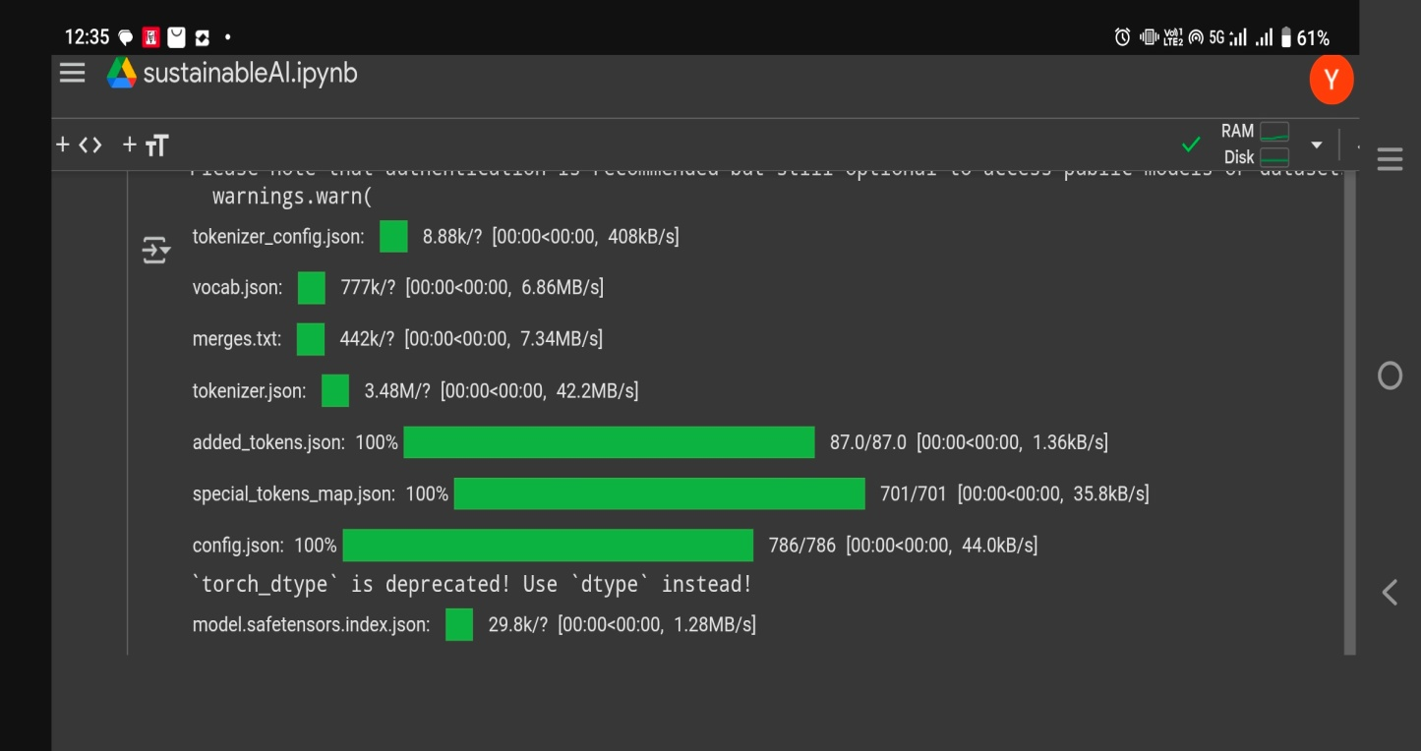

## OUTPUT:

